Corey Bernard

CST-105

6-11-17

Professor Hebert

NFL Draft App Storyboard

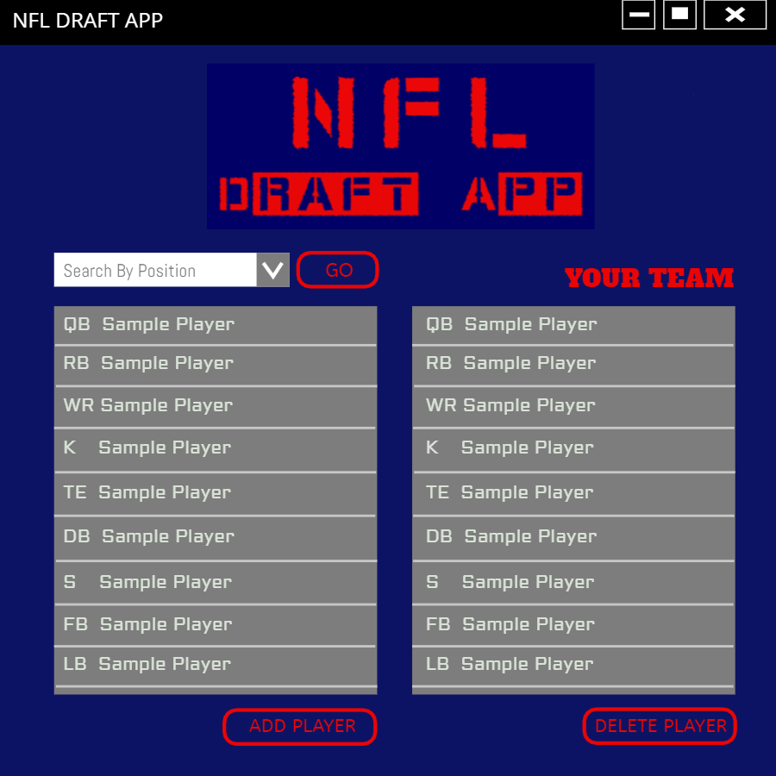

The Main Screen when the app opens. There will be a dropdown to search by player position. The list on the left will show available players. The list on the right will show your roster. The ADD PLAYER and DELETE PLAYER buttons will bring up confirmation popup windows. Double clicking a player will bring up the player info screen.

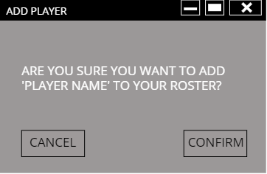

The ADD PLAYER button shows this popup confirmation window.

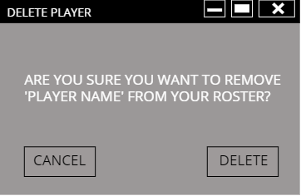

The DELETE PLAYER button shows this popup confirmation window.

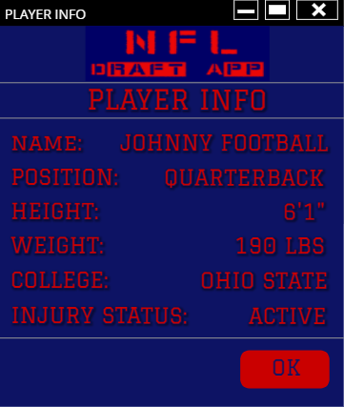

The PLAYER INFO screen will display when you double click on a player.